Q1) List all customers and the products they ordered with the order date. (Inner join)

Query:

select c.customer_id, c.company_name, o.order_date, p.product_name from

customers as c inner join orders as o on c.customer_id = o.customer_id

left join order_details as od on o.order_id = od.order_id

left join products as p on od.product_id = p.product_id

Output:

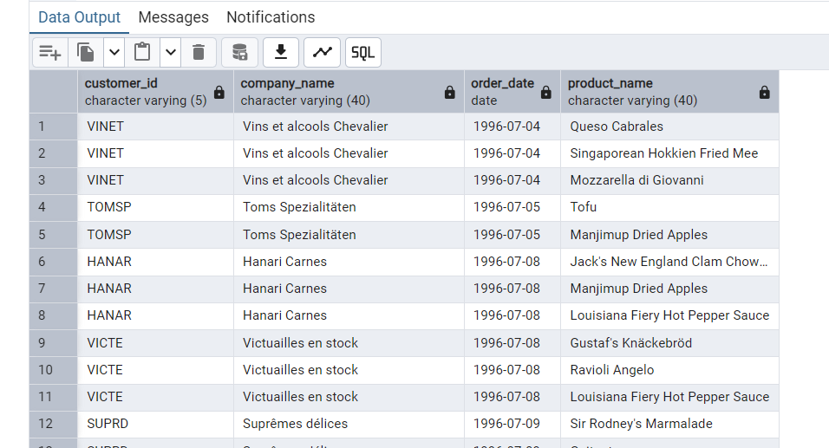

Q2) Show each order with customer, employee, shipper, and product info — even if some parts are missing.

Query:

select e.first_name, e.last_name, s.company_name, p.product_name, c.customer_id, c.company_name, o.order_id from products as p

left join order_details as od on p.product_id = od.product_id

left join orders as o on od.order_id = o.order_id

left join employees as e on o.employee_id = e.employee_id

left join orders as oa on e.employee_id = oa.order_id

left join customers as c on oa.customer_id = c.customer_id

left join shippers as s on c.company_name= s.company_name

Output:

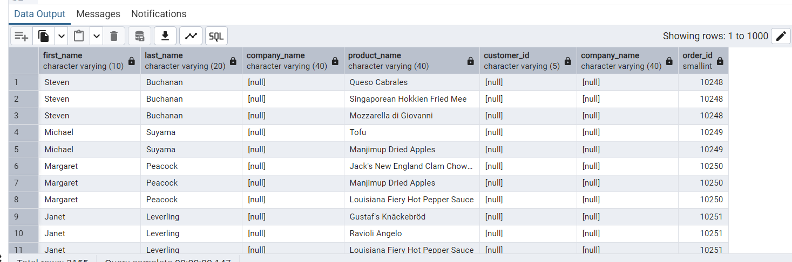

Q3) --Show all order details and products (include all products even if they were never ordered). (Right Join)

Query:

select * from order_details --#order_id, product_id, quanity

select * from products --#product_id, product_name

select od.order_id, od.product_id, od.quantity, p.product_name from order_details as od

right join products as p on p.product_id = od.product_id

Output:

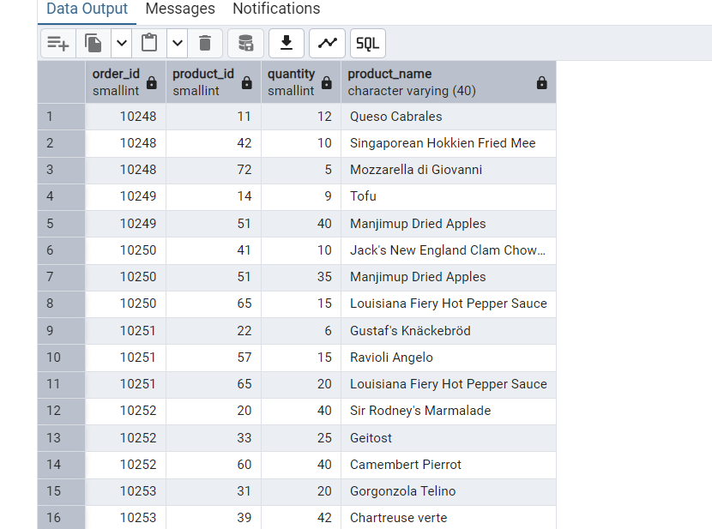

Q4) List all product categories and their products — including categories that have no products, and products that are not assigned to any category.(Outer Join)

Query:

select * from products---#product_id, product_name, #category_id

select * from categories -- #category_id, category_name

select p.product_id, p.product_name, c.category_name from products as p

full outer join categories as c on c.category_id = p.category_id

Output:

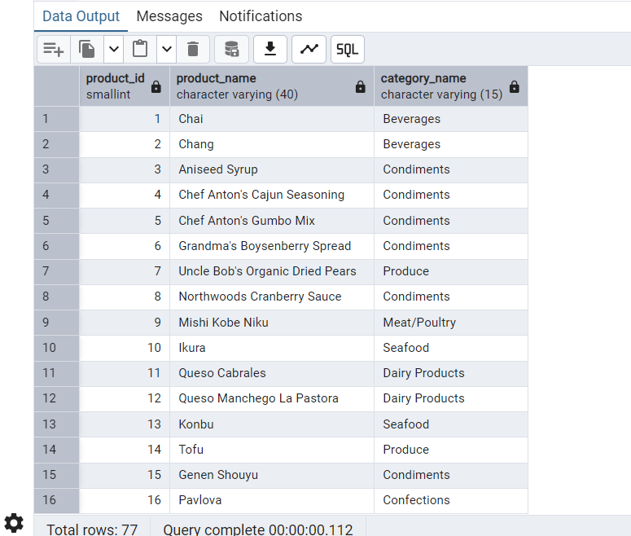

Q5) Show all possible product and category combinations

Query:

select p.product_id, p.product_name, c.category_name from products as p

cross join categories as c

Output:

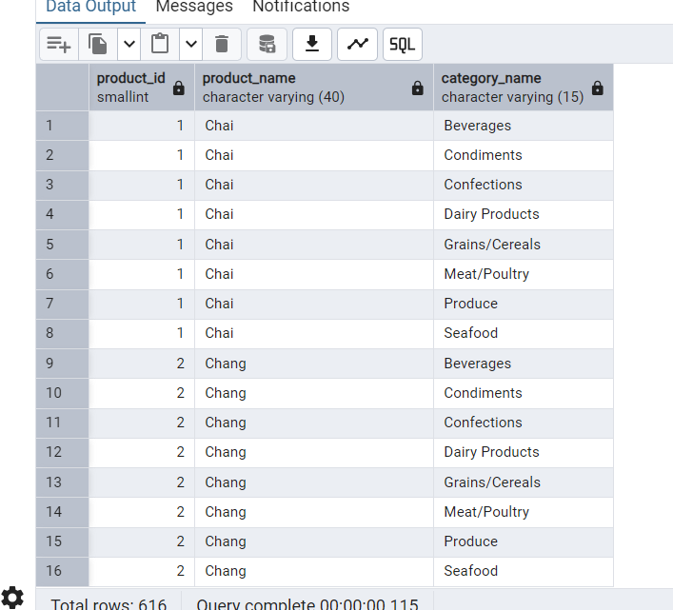

---Q7) List all customers who have not selected a shipping method.

Query:

select * from customers--#customer_id, #company_name

select * from shippers --#company_name

select * from orders where ship_via = null --#customer_id,#ship_via

select c.customer_id, c.company_name,o.ship_via from orders as o

left join customers as c on o.customer_id = c.customer_id

left join shippers as s on c.company_name = s.company_name where o.ship_via is null

Output:

